KENDRIYA VIDYALAYA NO1 MADURAI

MODEL QUESTION PAPER PREPARED IN SPELL II INSERVICE COURSE

SUMMATIVE ASSESSMENT-22011-2012

NAME: ___________________ STD: V “ ” ROLL NO: _____DATE :

SUBJECT: EVS TIME: 2 hrs.

|  |  |  |  |  |
| --- | --- | --- | --- | --- |
|  |  | Sign.of Invigilator: | |  |
| COMPETENCIES | OB. &R. | ID. &CL. | D.F. | TOTAL |
| Grade |  |  |  |  |

Sign.of Examiner

OBSERVATION AND REPORTING

I .Observe the following pictures and answer the questions.

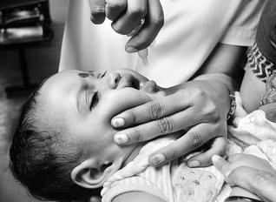1.Name the programme established by the Government of India in 1994 to eradicate polio.

________________________

2. ________________ is called farmer’s friend.

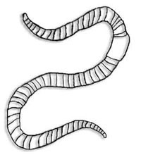

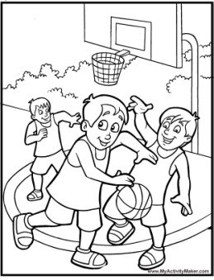

3.Name the game. _____________________________

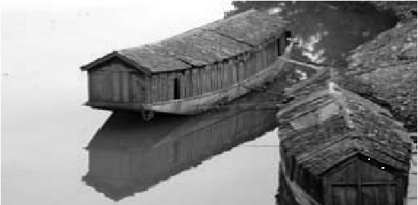4. Name the lake of Sri Nagar where GauravJani stayed in house boat.

___________________________

5

. W

hat is the full form

6

. What is a dam?

____________________

of LPG

?

__________________________

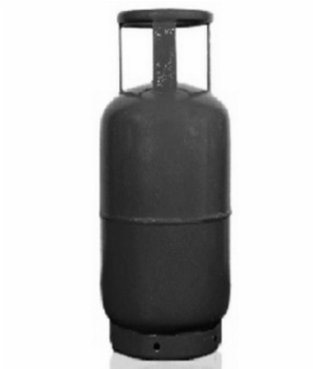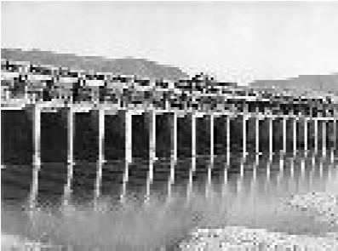

_____

______



7. _______________________was the head of the committee who framed our constitution.

II. Answer the following questions:

8.Write the method of making compost.

_____________________________________________________________________________

9

. What happens during

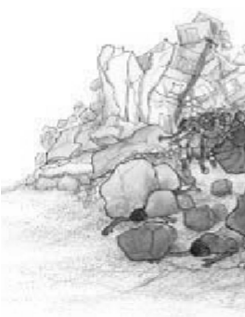

an

earthquake?

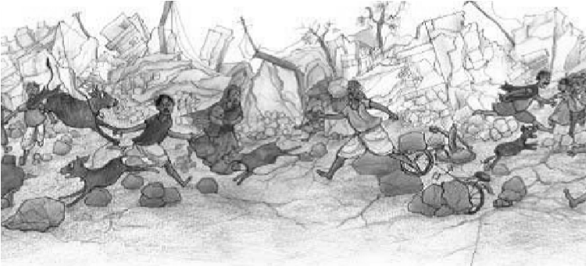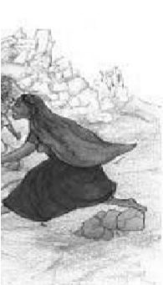

_____________________________________________________________________________ _____________________________________________________________________________

1. What is the use of stethoscope? Draw its diagram.

______________________________________________

______________________________________________

______________________________________________

______________________________________________

1. If you were to cool these hot things -dal, roti - in which ways you do so?

Dal _______________________________________________________________________

Roti ______________________________________________________________________

1. Mark the following in the map of India.
2. 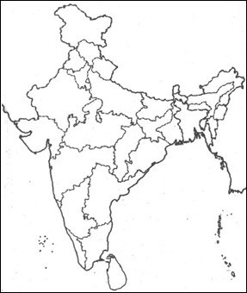Uttrakhand
3. Gujarat
4. Mizoram
5. Jharkhand
6. Bay of Bengal

IDENTIFICATION AND CLASSIFICATION

13. _________ ___________is the highest dam in India.

(a) Tehri Dam (b) Farakka dam (c) Hirakud dam (d) BhakhraNangal dam

14._____________________ is the respiratory gas.

(a) Nitrogen (b) Oxygen (c) Hydrogen (d) Ozone

15. _____________________ advocated the principle of dignity of work.

(a) Gandhiji (b) Subash Chandra Bose (c) Jawaharlal Nehru (d) Jenner

1. _____________________ farmingis known as slash and burn cultivation. (a) Step farming (b) Horticulture (c) Jhoom (d) none of these
2. Choose the correct statement.
3. Petroleum forms naturally and slowly.
4. Petroleum forms artificially and slowly.
5. Petroleum forms naturally and quickly.
6. Petroleum forms artificially and quickly.

18. List out any four irrigation systems.

_____________________________________________________________________________ 19. Suggest any two ways to save oil.

_____________________________________________________________________________

_____________________________________________________________________________

_____________________________________________________________________________

_____________________________________________________________________________

20. Differentiate between natural and synthetic fertilizer.

_____________________________________________________________________________

_____________________________________________________________________________

_____________________________________________________________________________ 21. Write the name of any two dams with its corresponding river.

_____________________________________________________________________________

_____________________________________________________________________________

_____________________________________________________________________________ 22. Complete the following table

|  |  |
| --- | --- |
| Your special habit or trait | To whom does it similar to? |
| 1. |  |
| 2. |  |

1. Differentiate between “life in city” and “life in village”.

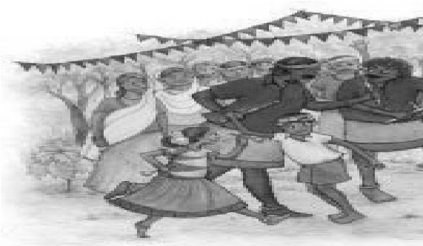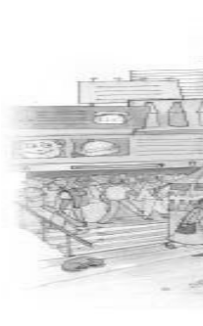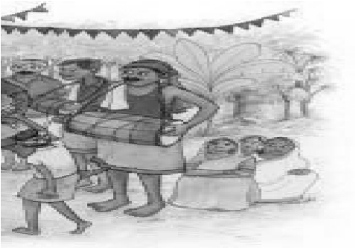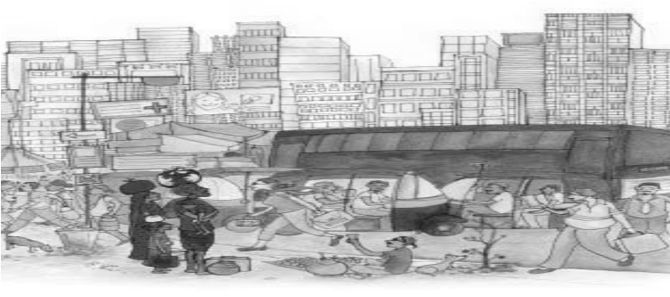

_____________________________________________________________________________

_____________________________________________________________________________

_____________________________________________________________________________

_____________________________________________________________________________

_____________________________________________________________________________

_____________________________________________________________________________ _____________________________________________________________________________

DISCOVERY OF FACTS

1. What is the full form of “OPV”?

__________________________________________________________________________

1. What do you mean by “cash crops”?

_____________________________________________________________________________

_____________________________________________________________________________

1. Intensity of earthquake is measured in ___________________ scale.
2. People who do menial work and placed at the lowest level of social ladder are known as

_______________________________.

1. Who is ‘Mukadam’?

_____________________________________________________________________________

_____________________________________________________________________________ 29. Write any two harvesting festival with its corresponding state.

_____________________________________________________________________________

_____________________________________________________________________________ 30. What do you mean by “pulse polio”?

_____________________________________________________________________________

_____________________________________________________________________________

_____________________________________________________________________________ 31. Write any two qualities of a good team.

_____________________________________________________________________________

_____________________________________________________________________________

_____________________________________________________________________________ 32. Write any two human activities due to which forests are disappearing.

_____________________________________________________________________________

_____________________________________________________________________________

_____________________________________________________________________________

33. Write about the difficulties faced by farmers who do not have their own land.

_____________________________________________________________________________

_____________________________________________________________________________

_____________________________________________________________________________

_____________________________________________________________________________ 34. Study the following table and write about the discovery by Mendel.

_______________________________________________________

Tt

Tt

t

T

T

Tt

Tt

t

Tt

tt

_______________________________________________________

_______________________________________________________ ______________________________________________________

_____________________________________________________________________________

_____________________________________________________________________________

_____________________________________________________________________________ _____________________________________________________________________________

_____________________________________________________________________________

_____________________________________________________________________________

_____________________________________________________________________________ _____________________________________________________________________________

_____________________________________________________________________________

_____________________________________________________________________________

_____________________________________________________________________________ _____________________________________________________________________________ IX.1)Give Reason

(a)CNG is preferred as a fuel to petrol and diesel in vehicles.

________________________________________________________________________

__________________________________________________

b) We see drops of water on the bathroom mirror when you take a hot shower in winter.

__________________________________________________________________________ __________________________________________________________________________

____________________________________________

2. Give short notes on

1. Right to forest act 2007 _____________________________________________________________________________

_____________________________________________________________________________ _____________________________________________________________________________ _____________________________________

1. Identical twins

_____________________________________________________________________________ _____________________________________________________________________________ _______________________________________________

3) Fill in the blanks

1. The instrument used to measure the intensity of an earthquake is called _____________________.
2. Forest dwellers are called _________________.

X. (a) What is Jhoom Farming?

_____________________________________________________________________________

_____________________________________________________________________________

_____________________________________________________________________________

_____________________________________________________________________________

_____________________________________________________________________________

_____________________________________________________________________________

_____________________________________________________________________________ _____________________________________________________________________________ ______________________________________________________

b)Draw and name any two implements used in farming.